**Deshmukh Shital Vivek**

**Email Id: Mobile:** ​+91​**-** ​**shitaldeshmukh9687@gmail.com**​8149980087

# OBJECTIVE

To obtain a responsible and challenging position where my education and work experience will have valuable application.

# CAREER PROFILE

* 6.8 Years of teaching experience.
* Presently working in Prof. Ramakrishna More Arts, Commerce and Science college Akurdi Pune.
* Self-motivated and quick learner of new concepts and technologies.
* Basic knowledge of software life cycle & implementation.

# TECHNICAL SKILLS

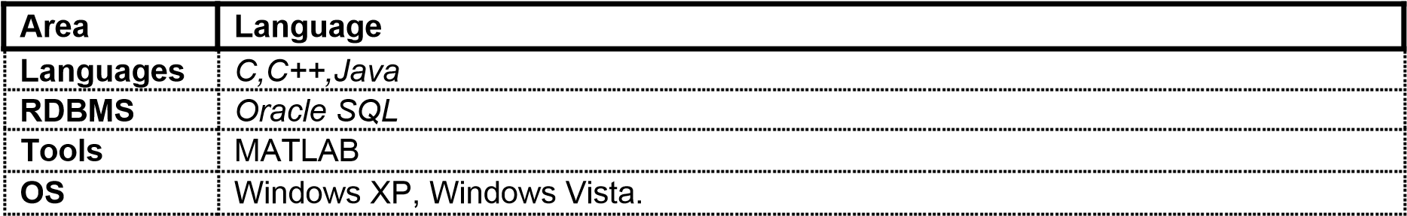

# EDUCATIONAL QUALIFICATION

|  |  |  |  |
| --- | --- | --- | --- |
| **Degree** | **Board/University** | **Year of Passing** | **% Obtained** |
| MCS | BAMU University | May-2009 | A+ |
| BCS | BAMU University | Oct-2007 | 65.00 |
| H.S.C. | Aurangabad Board | Feb-2004 | 58.00 |
| S.S.C | Aurangabad Board | March-2002 | 65.00 |

# EXPERIENCE SUMMARY

* 1. Years of experience in teaching for BCA & BCS College in Chhatrapati Shivaji college of Computer Science and Management Ambajogai Dist. Beed and 3.8 years of teaching experience in Prof. Ramakrishna More Arts, Commerce and Science college Akurdi Pune.

Following subjects conducted along with practical.

* Computer Fundamentals
* Digital Electronics
* Data Structure
* Programming in C
* Programming in C++
* Operating System
* Software Engineering
* Software Testing & Quality Assurance
* Recent Trends in IT(IoT)

Participated in paper setting and checking of semester examination conducted by university.

# ACADEMIC PROJECTS

❖ **Medical Imaging and Application (Jan 2009 – May 2009)**

Application is developed to enhance clarity of images in medical field like X-Ray, CT scan, MRI etc, where blur or unclear images are improved their visibility or clarity using this application. Further it used for better diagnosis of diseases. Application is built using MATLAB 7.0 tool. This application is designed under the guidance of medical experts.

Various industries can build such application according to their requirement using this Image processing application as prototype.

**Client:** ​Govt Hospital (Aurangabad)

**Technology used:** ​MATLAB 7.0

**Role:** ​Developer.

**Responsibilities:**

* Gathering information/requirements from medical experts.
* Design presentation on proposed application.
* Develop application using MATLAB.
* Unit testing of application.
* Managed and resolved design issues during development.
* Tested & Implemented application at client side.

# PERSONAL SKILLS

1. Ability to function as a team player and alternatively work independently to achieve objectives.
2. Self-motivated, able to set effective priorities to achieve immediate and long-term goals, and meet deadlines.
3. Knowledge of administrative needs.
4. Comprehensive problem solving abilities.
5. Willingness to learn new things.

# EXTRA CURRICULAR

* Present seminar on ​**Nano Technology**​ during MCS.
* Participated in international conference on ​**“Advances in computer Vision and Information**
* **Technology”** Attended seminar on “​conducted by IEEE.**Emerging Trends in IT**​ ​“ conducted in BAMU University.

# PERSONAL PARTICULARS

|  |  |
| --- | --- |
|  |  |
| **Name** | Deshmukh Shital Vivek |
| **Permanent Address** | Sec 27/A plot 479, Pradhikaran, Nigdi, Pune-411044, Maharashtra. |
| **Present Address** | Same. |
| **Birth Date**  **Marital Status**  **Nationality** | 09 June 1987  Married  Indian |